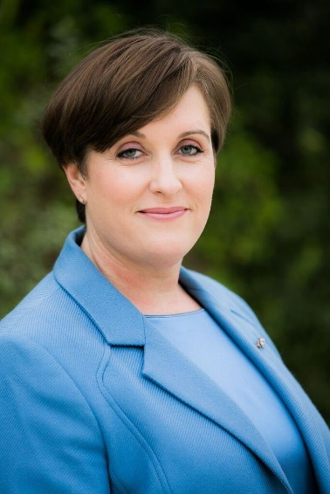
PROFESSIONAL PROFILE

DeAnne Steele, CFA®, CAIA

Managing Director

Private Client and Institutional Advisor

NMLS ID 1807422

PRIVATE BANK

CAO-816-16-07, 701 B Street, Suite 1650, San Diego, CA 92101

T 619.515.5607 | F 800.977.3503

deanne.steele@bofa.com

https://private.bankofamerica.com/deanne.steele/

Office of Supervisory Jurisdiction

Merrill Lynch, Pierce, Fenner & Smith Incorporated

CA9-165-03-01, 500 Newport Center Drive, Newport Beach, CA 92660

T 949.760.4539
DeAnne Steele is Managing Director and Private Client and Institutional Advisor at Bank of America Private Bank. She brings years of wealth management and leadership experience to her role with expertise in the many strategies and services within our firm to help drive impact for her clients and community. She welcomes any opportunity to share her experience and knowledge and is a frequent speaker on topics such as the global economy, financial markets, ESG (Environmental, Social and Governance), Women and Wealth and Diversity and Inclusion. She is the proud recipient of Bank of America’s Global and Diversity and Inclusion Award, a testament of her commitment to creating a world that harnesses the power of diversity by creating an inclusive environment in which all are empowered to share ideas. She is a founding executive sponsor of Bank of America’s women’s affinity group in San Diego and enjoys mentoring those building their careers in our company.
DeAnne and her team are responsible for providing families, executives, entrepreneurs and non-profit organizations with wealth management strategies customized to help meet their unique goals. Through this advice she helps them create the financial future they want for their families and communities. She works with her clients’ trusted advisors such as attorneys and accountants to provide integrated strategies including investment management, generational financial education to support responsible stewardship of family wealth, customized credit and lending designed to help clients maximize their balance sheets, tax planning, wealth structuring, trust and estate planning services, cash flow management, philanthropic planning, and other private banking services.
Prior to joining Bank of America Private Bank, DeAnne co-managed a mutual fund in addition to serving in various leadership and investment positions. She has written, co-authored and contributed to articles for various publications and has appeared on Reuters and Bloomberg Television.
DeAnne earned her Masters Degree in Business Administration, Finance, from UCLA Anderson School and a Bachelor of Arts, English and Political Science from UCLA. She has received the Chartered Financial Analyst® (CFA®) and Chartered Alternative Investment Analyst designations and is a member of the CFA Institute.
As first generation college-graduates in their family, she and her husband believe in giving back to their community and are active in many community organizations. She is a board member of the San Diego Center for Children which helps children and families struggling with mental, emotional and behavioral disorders.
DeAnne, her husband and teenage son have called San Diego home since 2006 and are the proud owners of a rescue dog named Falcon, adopted from Helen Woodward Animal Center in 2015. They are active participants in the jazz community. Her son plays trombone, her husband upright bass, and she is learning piano.
*Impact investing and/or Environmental, Social and Governance (ESG) managers may take into consideration factors beyond traditional financial information to select securities, which could result in relative investment performance deviating from other strategies or broad market benchmarks, depending on whether such sectors or investments are in or out of favor in the market. Further, ESG strategies may rely on certain values based criteria to eliminate exposures found in similar strategies or broad market benchmarks, which could also result in relative investment performance deviating.
*CFA® and Chartered Financial Analyst® are registered trademarks owned by CFA Institute.
*CAIA® is a registered certification mark owned and administered by the Chartered Alternative Investment Analyst Association.

