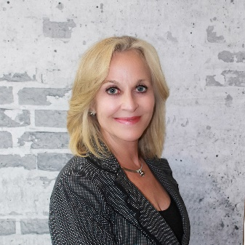
DeLinda Forsythe | CEO | Founder

Innovative Commercial Environments
9645 Scranton Rd | Suite 165 | San Diego, CA 92121
P (858) 947-7272 | F (858) 947-7273 | C (619) 890-2919
DeLinda@icesd.com | www.icesd.com

DeLinda has thrived in the contract furniture industry for 30 plus years. By far the most rewarding portion of those years has been since opening ICE in 2006. The impetus for ICE was her son’s acceptance into Georgetown University. As a single mother with few financial options to help him achieve his educational goals, DeLinda was forced to try entrepreneurship. It was a leap of faith that proved fortuitous.

Inc. Magazine has ranked ICE in the top 5000 Fastest Growing Companies in the US 6 times 2014-2019; only (4) San Diego companies have ever achieved this recognition by Inc.

In 2013 DeLinda noted the trend for more residential furniture in offices and ICE enhanced their capabilities by adding hospitality furnishings to their scope of services. This influenced growth with the ability to furnish restaurants, hotels, night clubs but also has led to ICE’s reputation as San Diego’s most creative office furniture dealership. ICE has been awarded (2) highly coveted IIDA Calibre awards for The Music Box and for the UTC Aventine public spaces.

DeLinda started a new company, WorkShop, in 2015 which provides live edge conference tables, custom furniture and a brewery inspired benching system called WorkiBeam. WorkShop furniture is made in San Diego. In 2011 and 2017 ICE took home Best of NeoConnect awards for their custom furniture designs. WorkShop was recently integrated into ICE.

Teknion selected ICE as their exclusive San Diego distributor in 2017 which has allowed ICE to partner with some of San Diego’s most prestigious companies. Teknion furniture can be seen at ICE’s new showroom in Sorrento Valley. The showroom reflects ICE’s creative, biophilic and welcoming office design perspective.

DeLinda believes in serving the community. She is Board Chair of the San Diego Economic Development Corporation Foundation, she Co-Chairs the Athena Pinnacle Committee, serves on the NAIOP Foundation board, the TranscenDANCE board and has volunteered over the years with TERI, MOM and Reality Changers. She actively coordinates furniture donations for San Diego non-profits through existing ICE customers.

She is often asked to speak professionally on leadership, conscious capitalism, corporate culture development and mentorship. ICE has a reputation as being an organization with an extraordinary corporate culture which fosters service excellence and has led to extensive employee growth and retention. DeLinda personally mentors and encourages women with a focus on the Millennial generation, which can be summed up in a quote by Helen Keller; “Life is an exciting business, and most exciting when it is lived for others.”

She has remarried and in addition to her son, through marriage she has 3 daughters and 8 grandchildren.
In 2014 DeLinda was a SDBJ Women Who Mean Business winner and in 2019 named in the SDBJ Top 500 Most Influential People in San Diego.

